CUSTOMER JOURNEY MAP

|  |  |
| --- | --- |
| DATE | 1**7** November 2022 |
| TEAM ID | PNTTMID50609 |
| TITLE | IOT BASED CHILD SAFETY GADGET FOR MONITORING AND NOTIFICATION |
| TEAM LEAD | Selshia M |
| TEAM MEMBERS | Banupriya K  Subhashini G  Sandhiya subashree |
|  |  |

User jounery:

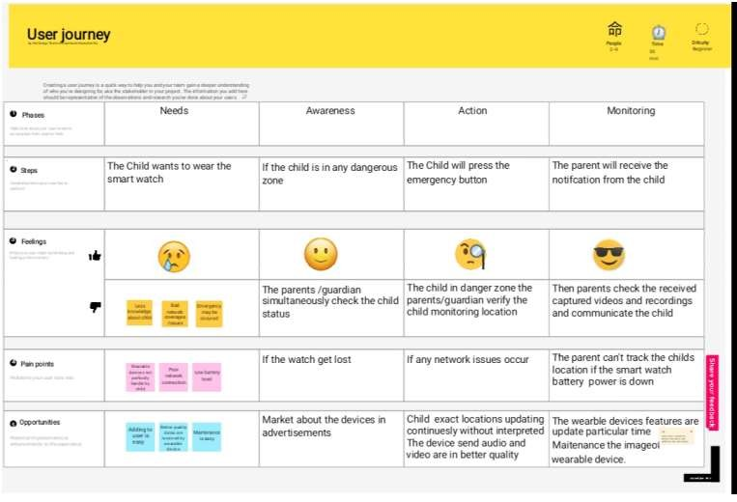 Children can go wherever or do whatever they choose to do. We have experienced numerous issues, mishaps, and occurrences as we have grown older. Reduce these events in the lives of future children.

|  |  |  |  |  |
| --- | --- | --- | --- | --- |
| **Phase** | **Needs** | **Awareness** | **Action** | **Monitoring** |
| Steps | Safety and security | Should know about the children location | Children must wear mask | The Parents will receive the notifications |
| Feelings | 😥  Children get Fear While unsafe | 😊  Parents check simultaneously | 🧐  Must produce these kind of Gadgets | 😎  Parents capture videos, pictures, and recordings and communicate the child |
| Opportunities | They need gadget anytime | Market about the device in advertisement | Child exact location updating continuously without any interruptions | Maintenance the image of wearable device |